**ENGLISH 2 – AMERICAN JETSTREAM – SPEAKING QUESTIONS:**

1. **Which animal do you think is the most dangerous?**

* **I think the most dangerous female dragon.**
* **Because the female dragon is very strong and fierce.**

1. **Which animal do you think is the least dangerous?**

* **I think the cow is the least dangerous.**
* **because people used to say stupid like a cow, a stupid cow is not dangerous.**

1. Read the short text about the movie “JAWS”:

*“Jaws” is a 1975 American thriller film directed by Steven Spielberg and based on Peter Benchley’s 1974 novel of the same name. In the film, a man-eating great white shark attacks beachgoers at a summer resort town, prompting police chief Martin Brody (Roy Scheider) to hunt it with the help of a marine biologist (Richard Dreyfuss) and a professional shark hunter (Robert Shaw). Murray Hamilton plays the mayor, and Lorraine Gary portrays Brody’s wife. The screenplay is credited to Benchley, who wrote the first drafts, and actor-writer Carl Gottlieb, who rewrote the script during principal photography.*

*“Jaws” was the prototypical summer blockbuster of 1975.*

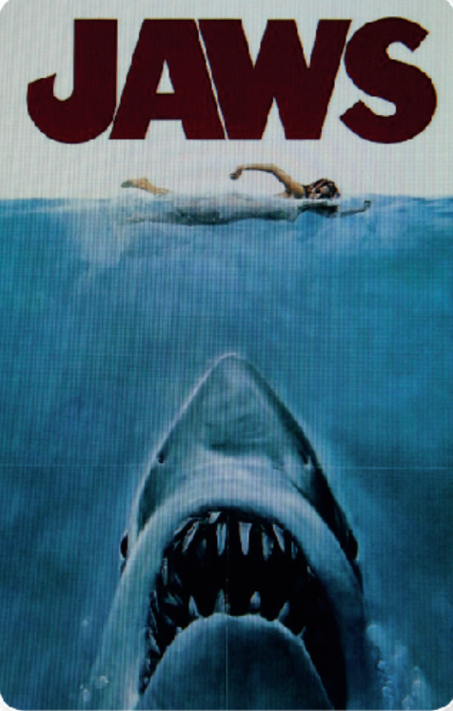

* **A lot of people think that “Jaws” may be responsible for creating our fear of sharks. What do you think?**
* **The reason we are afraid of sharks is because they are very aggressive, cold-blooded, brutal and have great attack power.**
* **Can you think of an animal more dangerous than a shark?**
* **I think the aquatic animal more dangerous than a shark is the saltwater alligator.**

1. **What are you afraid of?**

* I am really afraid of the spiders,
* Because it have many leg and I am feeling unsafe when dealing with spiders. I always stay away from spiders when I see them or I used spray the insect raid to kill them.

1. **What’s the scariest movie you’ve ever seen?**

* The scariest movie I ever seen is a shark attack.
* Because it have lots of corpses and blood.

1. **Do you like giving presentations?**

* Yes, I definitely do like giving a presentations.
* I like to speaking and explaining my ideas clearly in a strong presentations.
* This can help me to show myself better.

1. **Why do some people feel nervous about giving presentations?**

* In my opinion people afraid, about people that they know more than them in their presentations.
* For example, when you have a presentations in university you may be anxious about professors.
* In addition, presenters are more likely to forget what to say, when they are nervous or stressed.

1. **What do you usually do to make you more confident before giving a presentation?**

* In my idea, best way to become successful in presentation is to concentrate on what you want to present and how you want to do it. Also rehearsal in same room as you should present, can improve your presentation level, practice a lot beforehand. You become more confident.
* I will do a mock presentation in front of friends or even without any audience will help.

1. **To perform your best, what do you usually do to manage your fear of public speaking?**

* In my idea, best way to become successful in presentation is to concentrate on what you want to present and how you want to do it. Also rehearsal in same room as you should present, can improve your presentation level, practice a lot beforehand. You become more confident.
* I will do a mock presentation in front of friends or even without any audience will help.

1. **What do you think people should do before giving a presentation?**

* I thing every one should rehearsal in same room as you should preasent, can improve your presentation level, preatice a lot beforehand. You become more confident.
* I will do a mock presentation in front of friends or even without any audience whill help.

1. **How can visual aids help in a presentation?**

* It can help them to keep in their mind for longer time than just hearing.
* Improve the efficiency of a good presentation.

1. **How can people improve their public speaking skills?**

* Plan appropriately.
* Practice.
* Engage with your audience.
* Pay attention to body language.
* Think positively.
* Start with a smile.
* Start off with a story.
* Let others do the talking

**GOOD LUCK**